MOCK SCREENS FOR REVISED PBTOOLS
(ANALYSIS – wizard approach)

A. Phenotypic Analysis – Single-environment

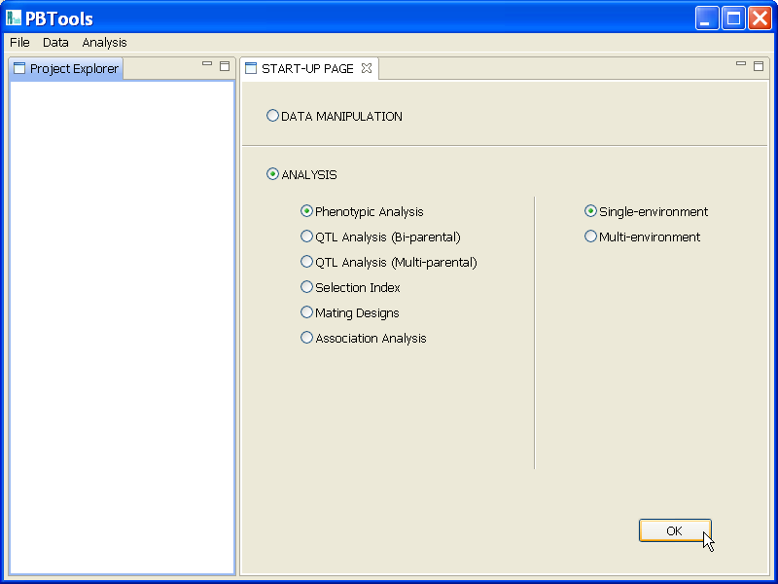

From START-UP Page:

Step 1. Selecting one input file

The user needs to specify the format and name of one input file.
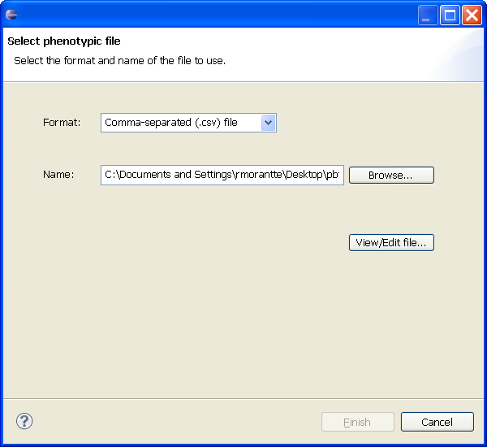

Data can be viewed/edited when the View/Edit data… button is pressed.

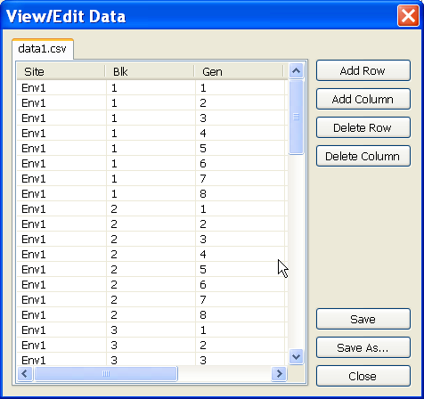

Rows/columns may be added to or deleted from the data set, for adding/removing observations/variables. The Save button is used if the user wants to save changes to the file. If he wants to save the changes into a different file, he uses the Save As… button. In this case, the user is informed that the input file will now be replaced by the revised file with the new file name. The user needs to press the Close button to close this dialog box and return to the wizard.

After pressing the Next button, data file will be copied into the Data subfolder of the project folder.

Step 2. Model specification page

The user needs to choose the type of design, and specify the response variable(s) and factors to be used for the analysis.

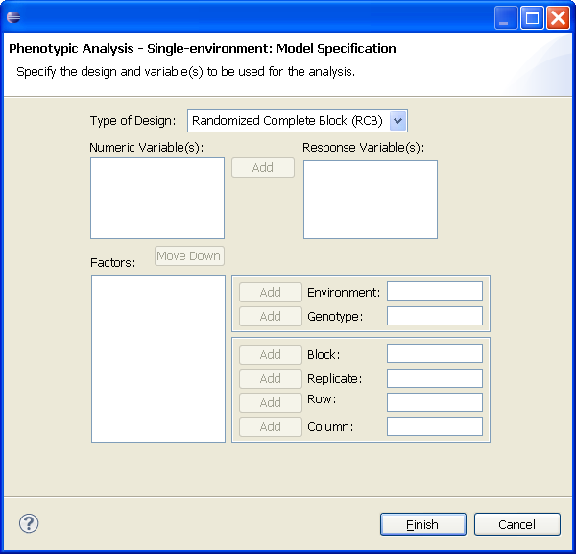

For the type of design, five options are currently available: Randomized Complete Block (RCB), Augmented RCB, Augmented Latin Square, Alpha-Lattice, and Row-Column.

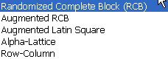
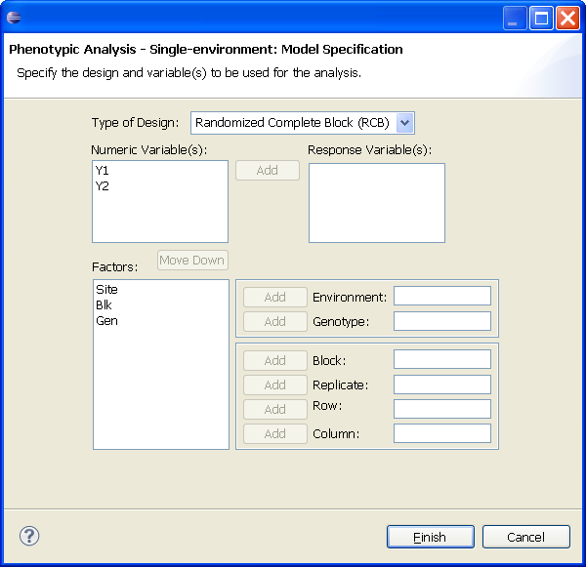

If all the necessary fields have been filled-up, the user can click on the Finish button to proceed with the analysis or the Next button to view/edit the options for the analysis.

Step 3. General options specification and Fixed/random factor specification pages

The user can edit the default options and click on the Finish button to proceed with the analysis using default options for genotype or click on the Next button to edit options for genotype as fixed or random and then click Finish.
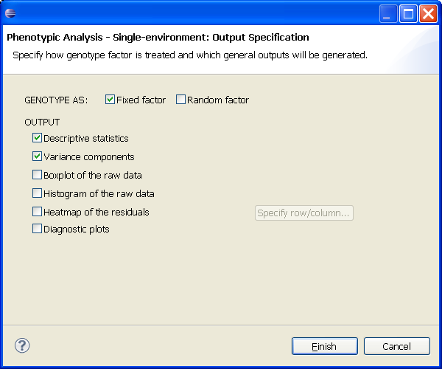

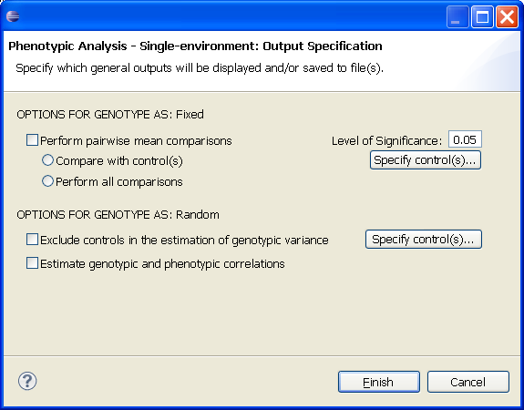

Output will be saved in the subfolder Phenotypic_Single of the Output folder of the current project. Text output will be displayed on the right panel of PBTools.

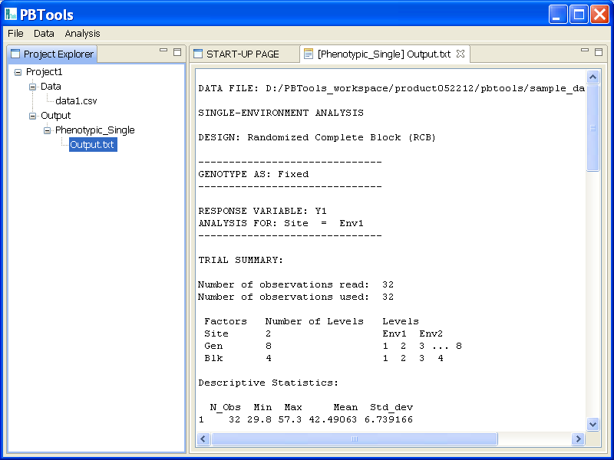

From the menu:

Phenotypic Analysis – Multi-environment

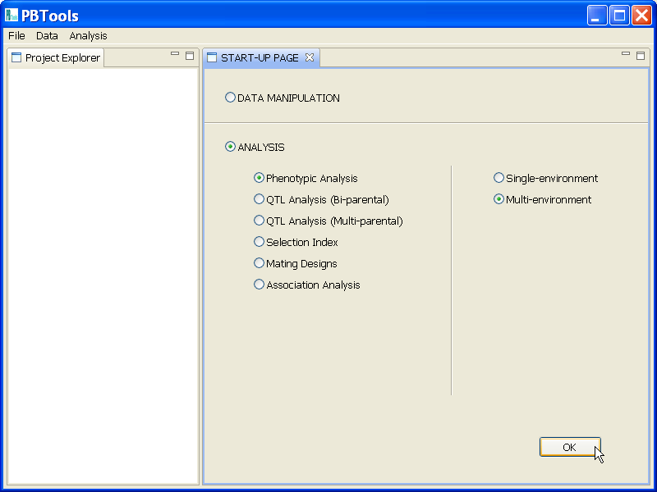

Wizard:

Step 1. Select option for phenotypic analysis – multi-environment.

a. One-stage

The user clicks on the One-stage button and then presses the Next button.
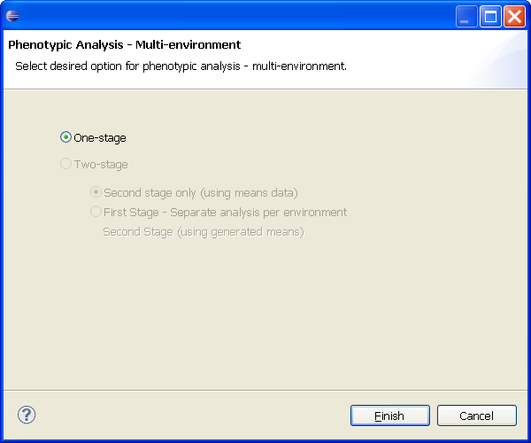

The user needs to specify the format and name of one input file.

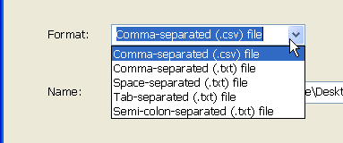
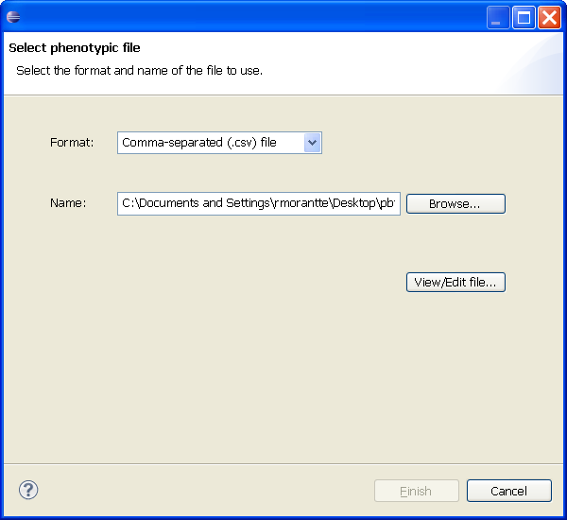

The user needs to choose the type of design, and specify the response variable(s) and factors to be used for the analysis. If all the necessary fields have been filled-up, the user can click on the Finish button to proceed with the analysis or the Next button to view/edit the options for the analysis.

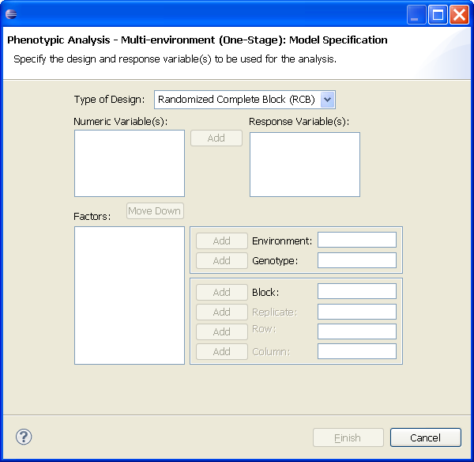

As of the moment, three design options are available: RCB, Alpha-Lattice, and Row-Column.

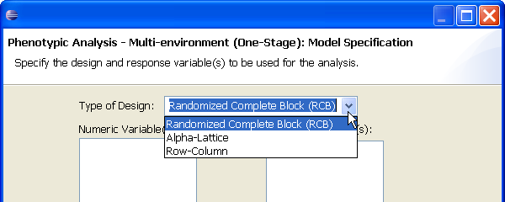

The user can edit the default options and click on the Finish button to proceed with the analysis using default options for genotype or click on the Next button to edit options for genotype as fixed or random and then clicking on the Finish button on that page.

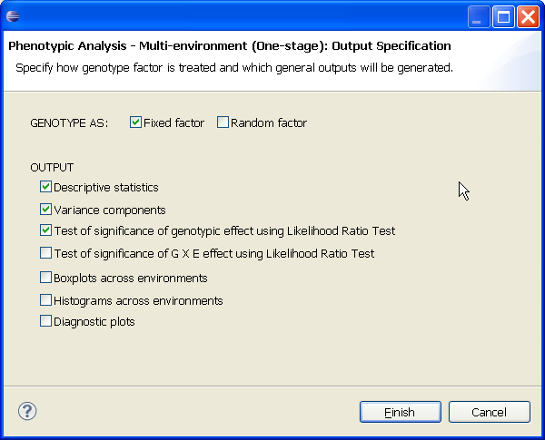

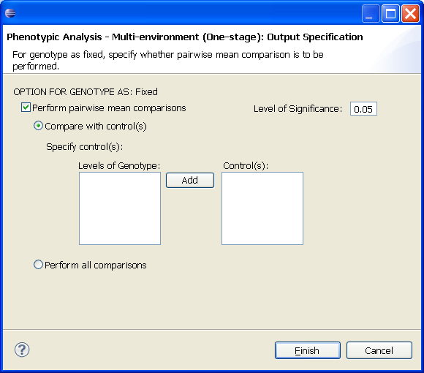

b. Two-stage

The user clicks on the Two-stage button and then presses the Next button. If his input file contains means generated per environment, he can proceed with the option Second stage only (using means data). (Otherwise, if he has raw data coming from different environments (with possible different designs), he can choose the second option. – TO BE ADDED)

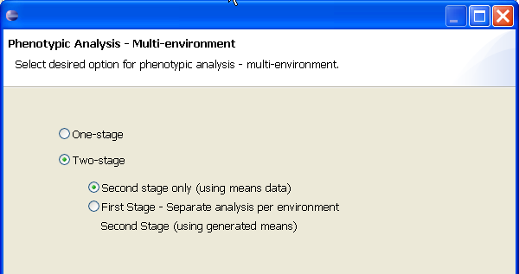

The user needs to specify the format and name of one input file.

The user needs to choose the weight option, and specify the response variable(s) (for the means) and corresponding standard error (if needed), residual variance, and number of replicates variables for each response variable, as well as the factors to be used for the analysis. If all the necessary fields have been filled-up, the user can click on the Finish button to proceed with the analysis or the Next button to view/edit the options for the analysis.

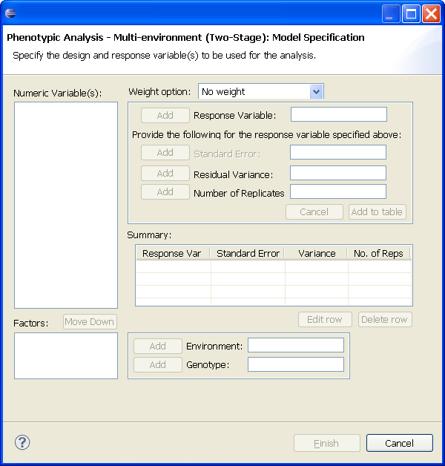

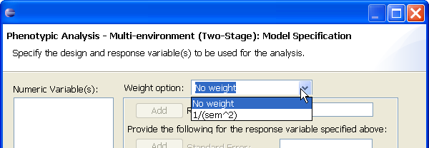

The user can edit the default options and click on the Finish button to proceed with the analysis using default options for genotype or click on the Next button to edit options for genotype as fixed or random and then clicking on the Finish button on that page.

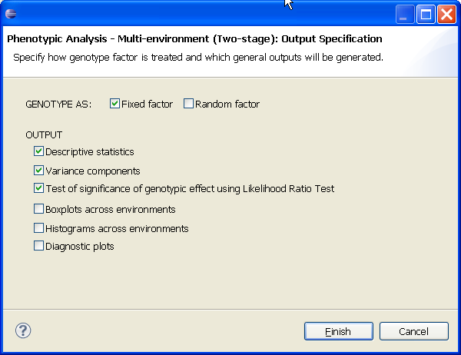

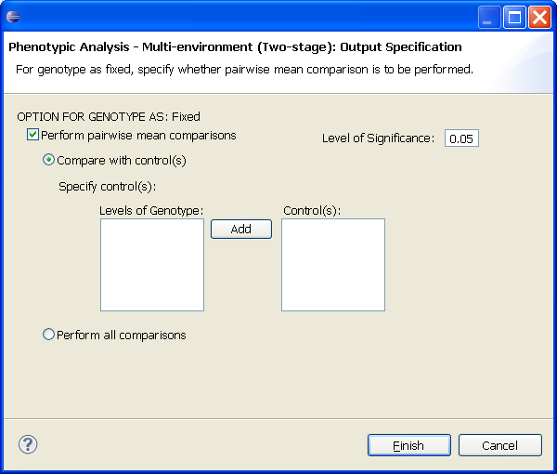
QTL Analysis (Bi-parental) – Single–environment

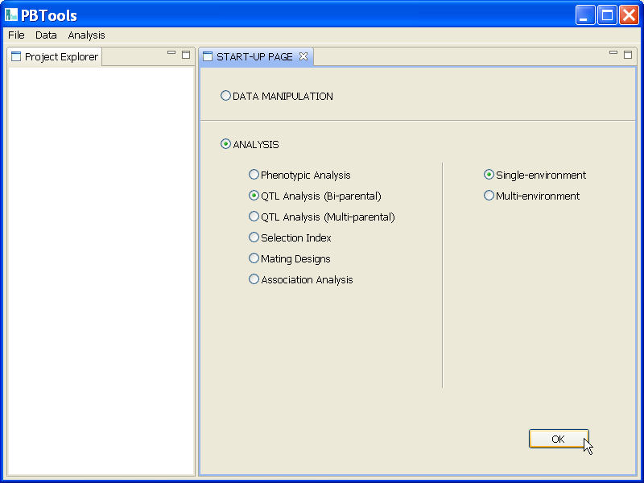

Wizard

Step 1. Select option for reading in input file(s).

a. PBTools
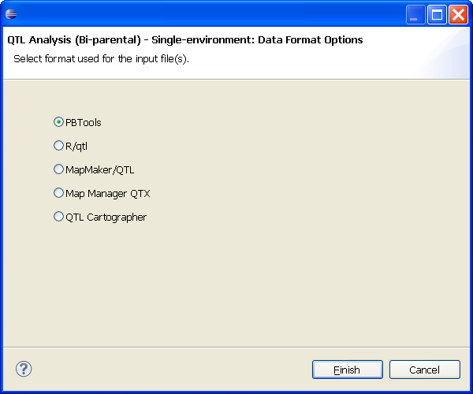

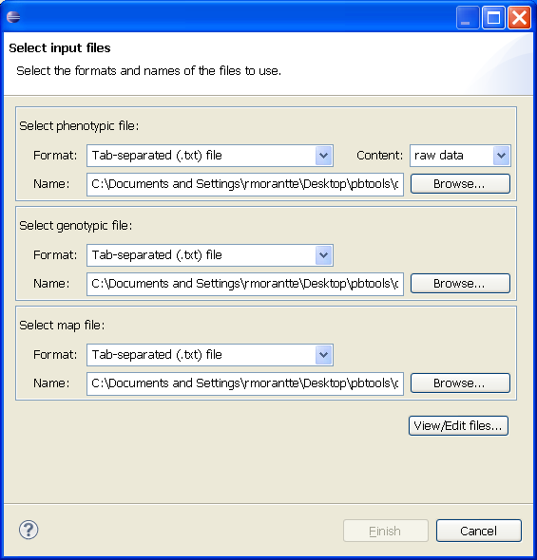

b. R/Qtl

- csv

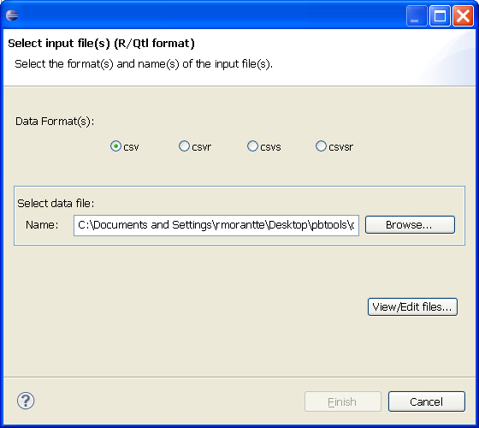

- csvr

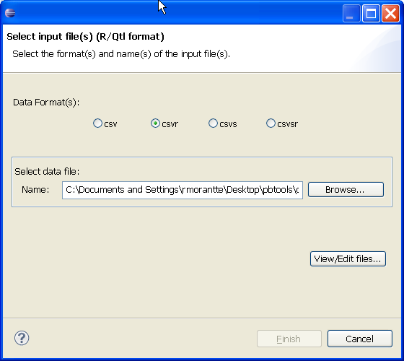
- csvs

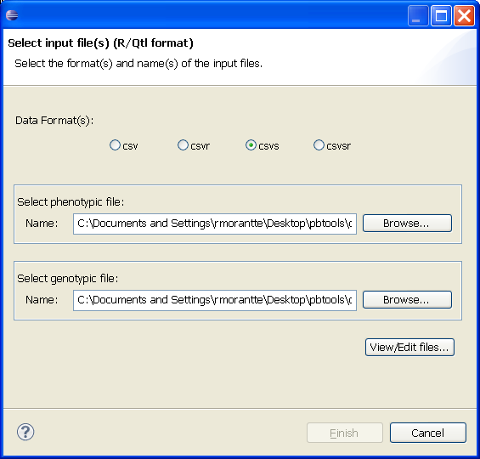

- csvsr

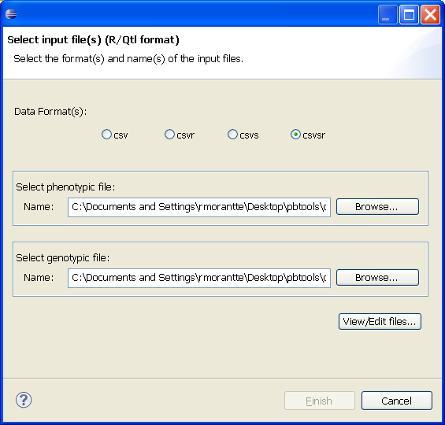
- MapMaker

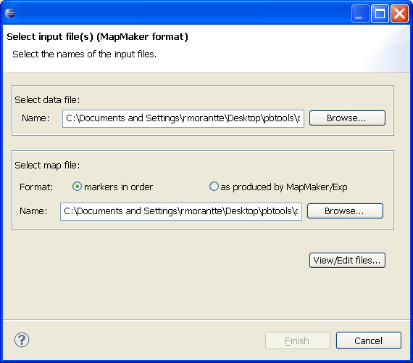

- Map Manager QTX

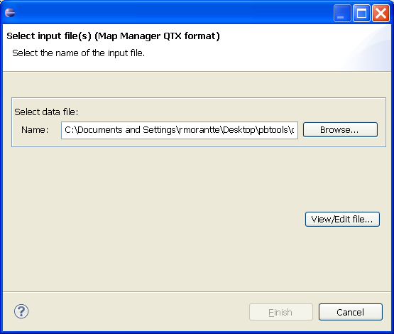

- QTL Cartographer

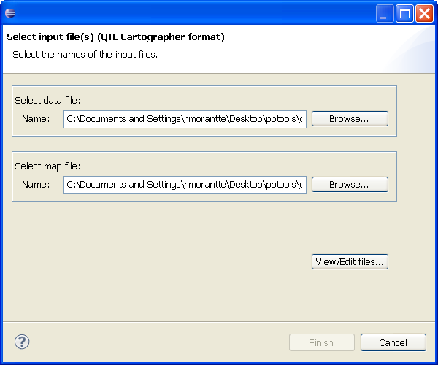

Step 2. Model Specification page

a. PBTools

- with means data as input
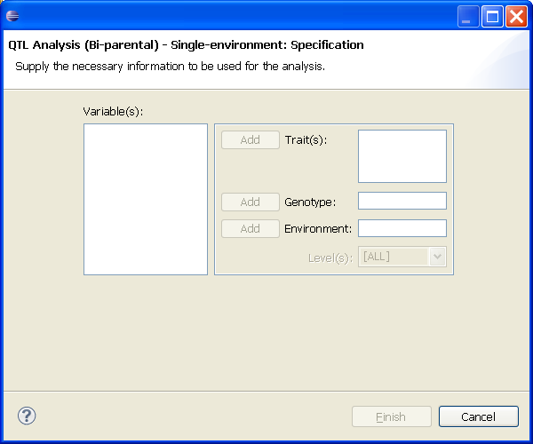

- with raw data as input
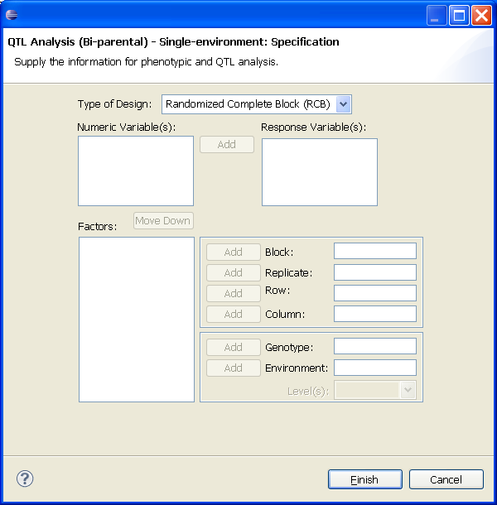
a. other data input formats

Step 3. Options Specification page
The user can edit the default options for the analysis. The user can click on the Finish button to proceed.

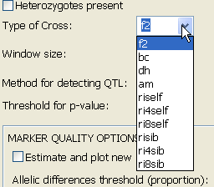
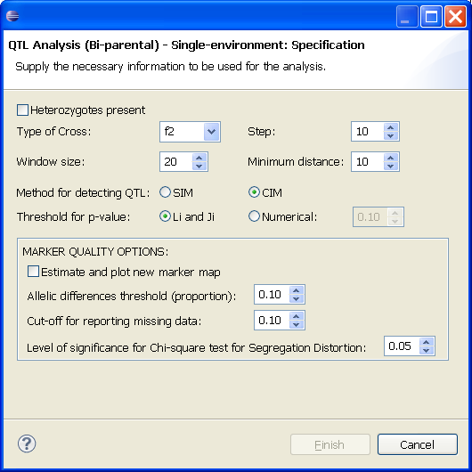

TO BE ADDED:

QTL Analysis (Bi-parental) – Multi–environment

QTL Analysis (Multi-parental) – Single–environment

QTL Analysis (Multi-parental) – Multi–environment

Selection Index – Single-environment

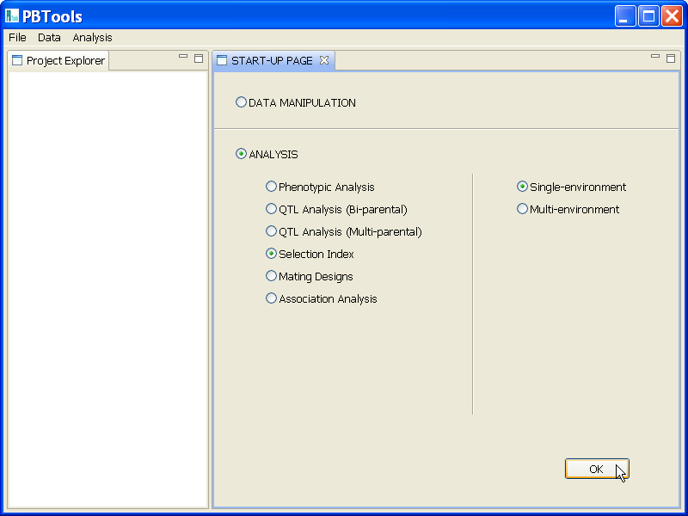

Wizard

Step 1. Choosing selection index to use

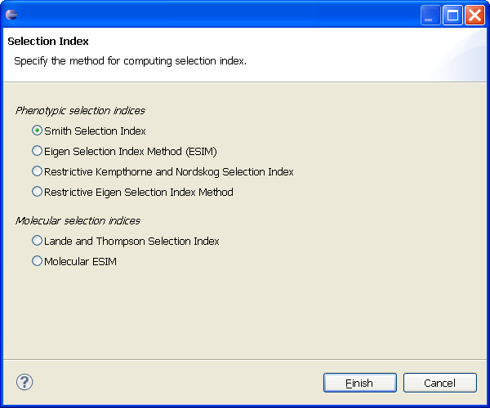

Step 2. Selecting input files

- using any of the phenotypic selection indices

- using any of the molecular selection indices

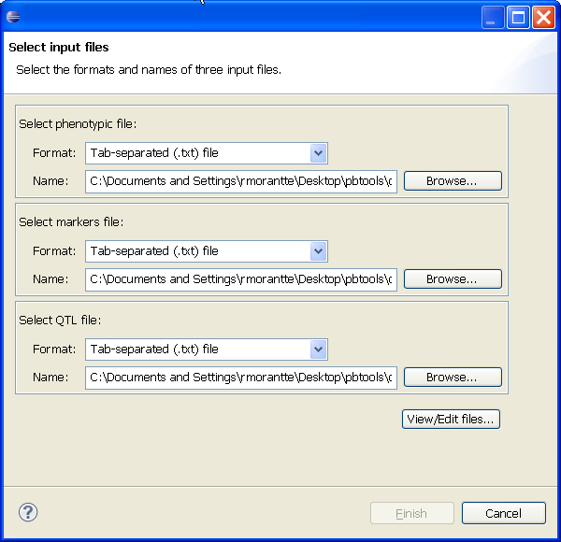

Step 3. Option specification page

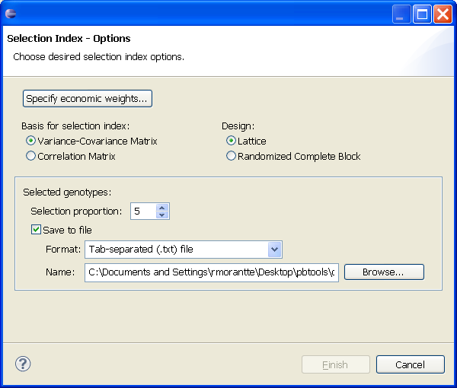

TO BE ADDED:

Selection Index – Multi-environment

Mating Designs – Single-environment

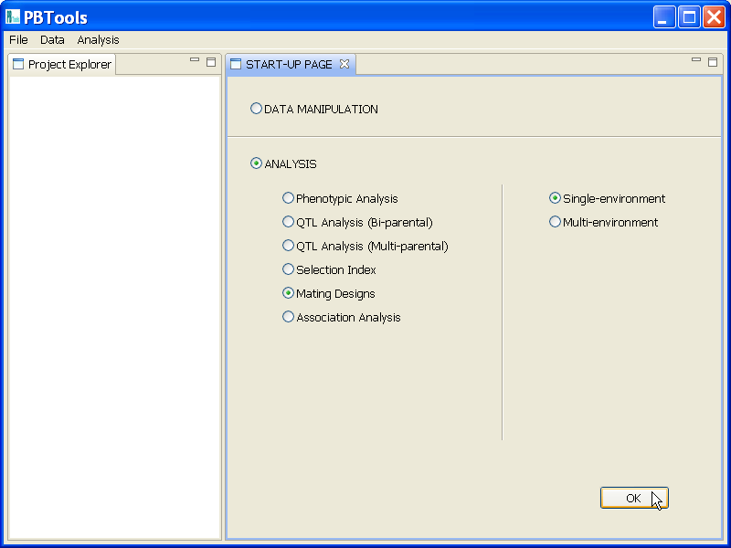

Wizard

Step 1. Selecting a mating design.

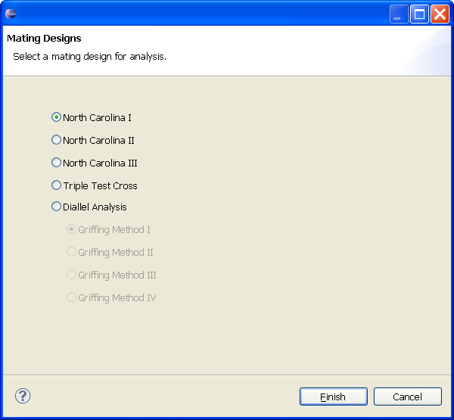

Step 2. Selecting one input file

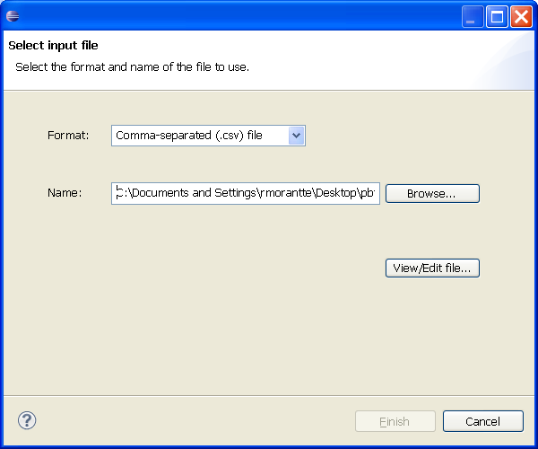

Step 3. Model specification page

- North Carolina I

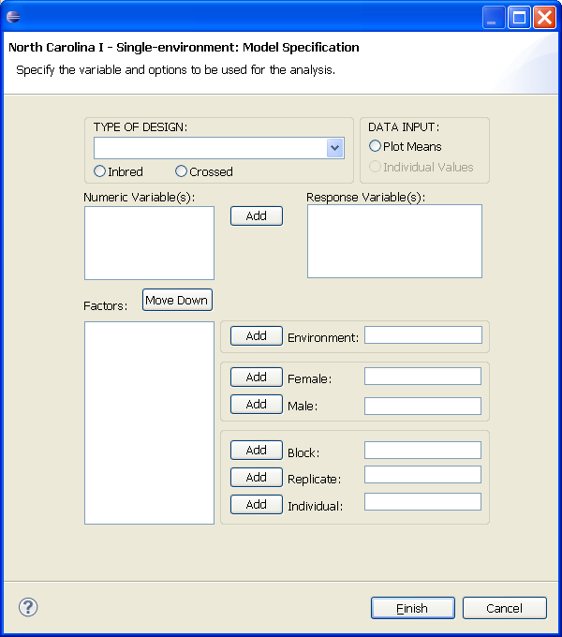

- North Carolina II

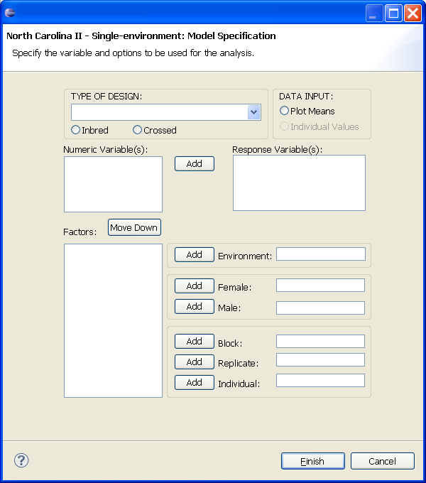

- North Carolina III

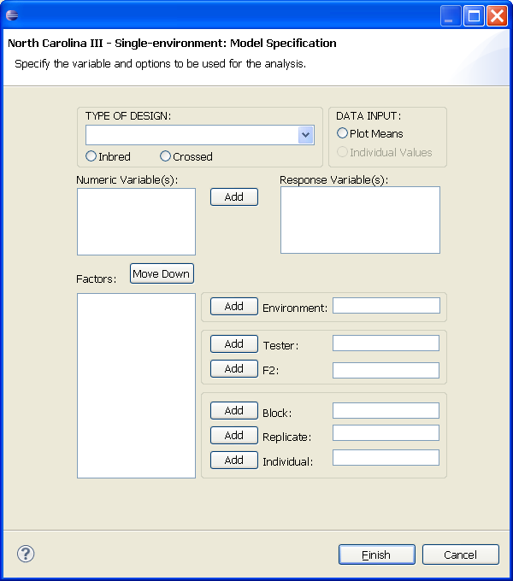

- Triple Test Cross (no parents)

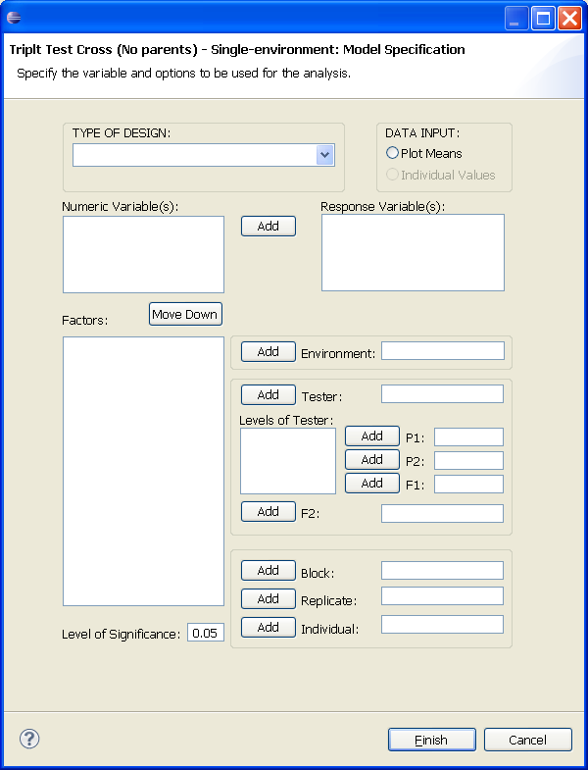

- Triple Test Cross (including parents)

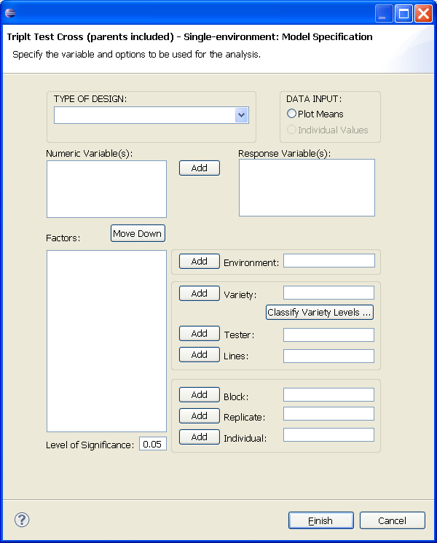

- Diallel Analysis (Griffing Method I)

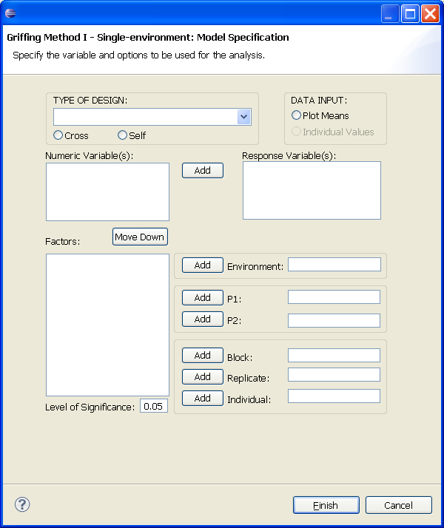

- Diallel Analysis (Griffing Method II)

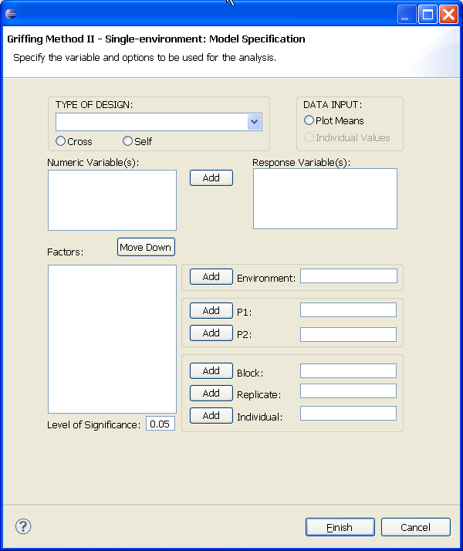

- Diallel Analysis (Griffing Method III)

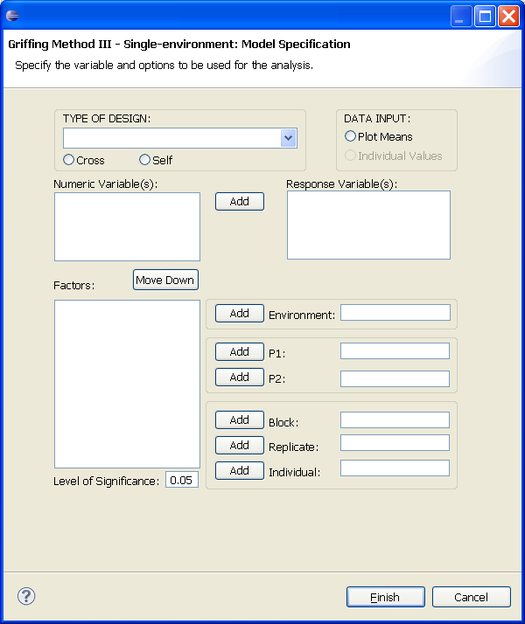

- Diallel Analysis (Griffing Method IV)

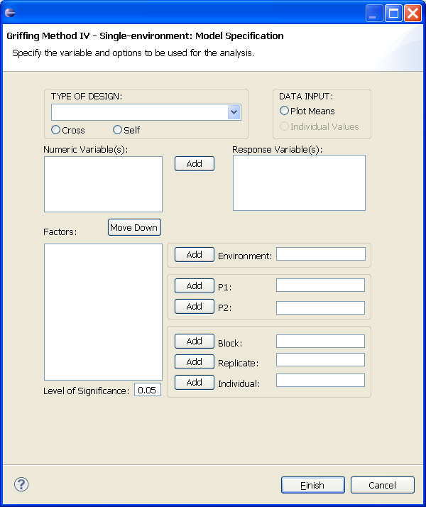

TO BE ADDED:

Mating Designs – Multi-environment

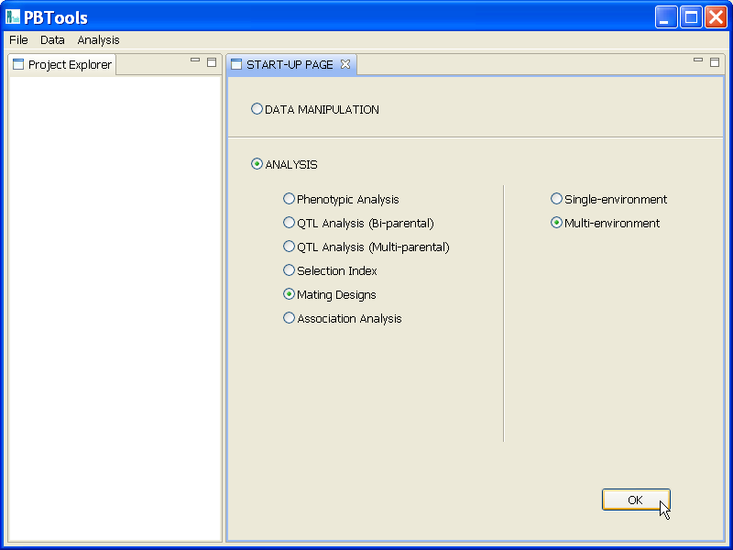

Association Analysis – Single-environment

Association Analysis – Multi-environment

TO BE ADDED:
MENU DISCUSSION

